# Jenkins - Setup Build Jobs

Let's create and run a job in Jenkins for simple **HelloWorld** in Java.

**Step 1:** Go to the Jenkins dashboard and click on the New Item.

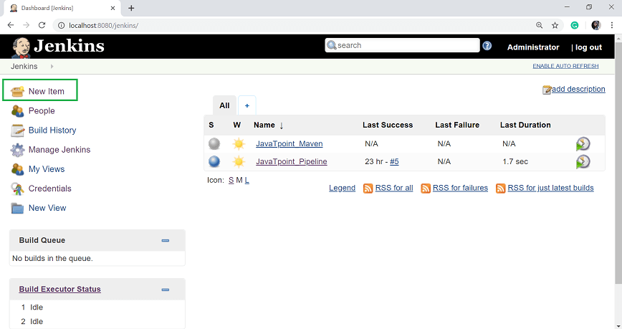

**Step 2:** In the next page, enter the item name, and select the 'Freestyle project' option. And click OK. Here, my item name is HelloWorld.

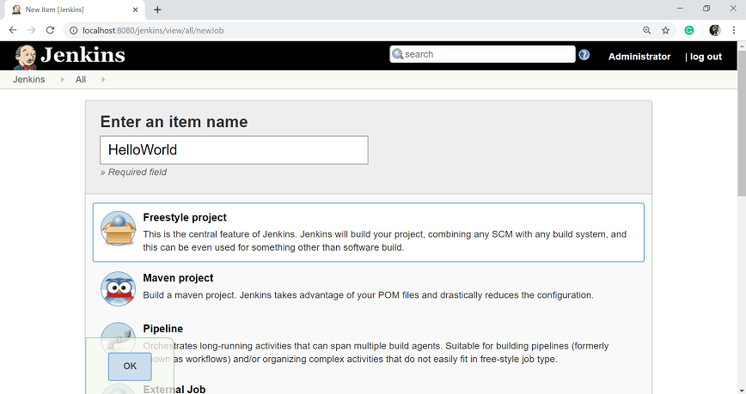

**Step 3:** When you enter the OK, you will get a configuration page. Enter the details of the project in the Description section.

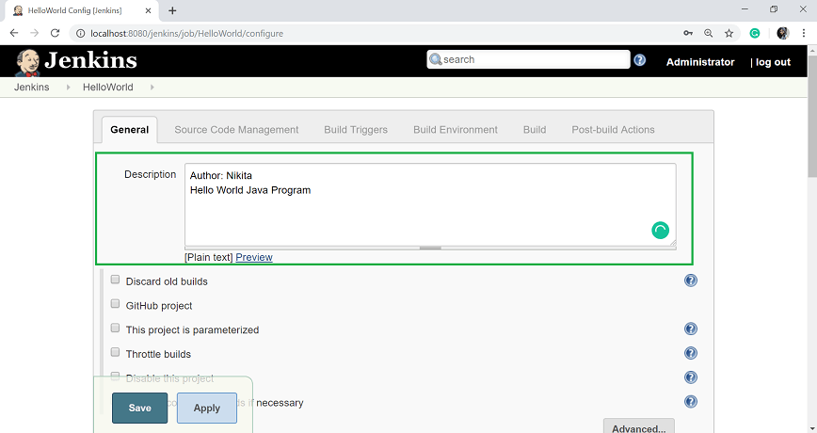

**Step 4:** On the Source Code Management section, select the **Git** option, and specify the Repository URL.

To do that you should have proper github setup on your system. To do the github setup:

* First, you have to create a project in java. Here, I created a simple **HelloWorld** program and saved it to one folder i.e. C:\GitRepo. Compile the HelloWorld.java file.

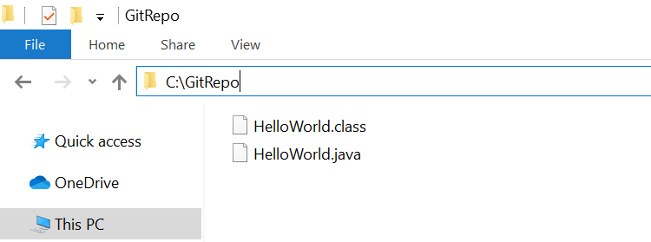

* Now create a project in your GitHub account and give the Repository name. Here my repository name is HelloWorld.

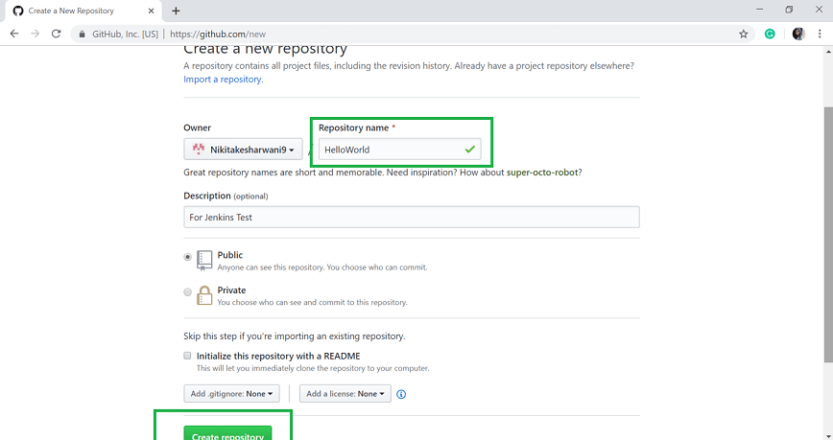

* Click on **Create repository**.

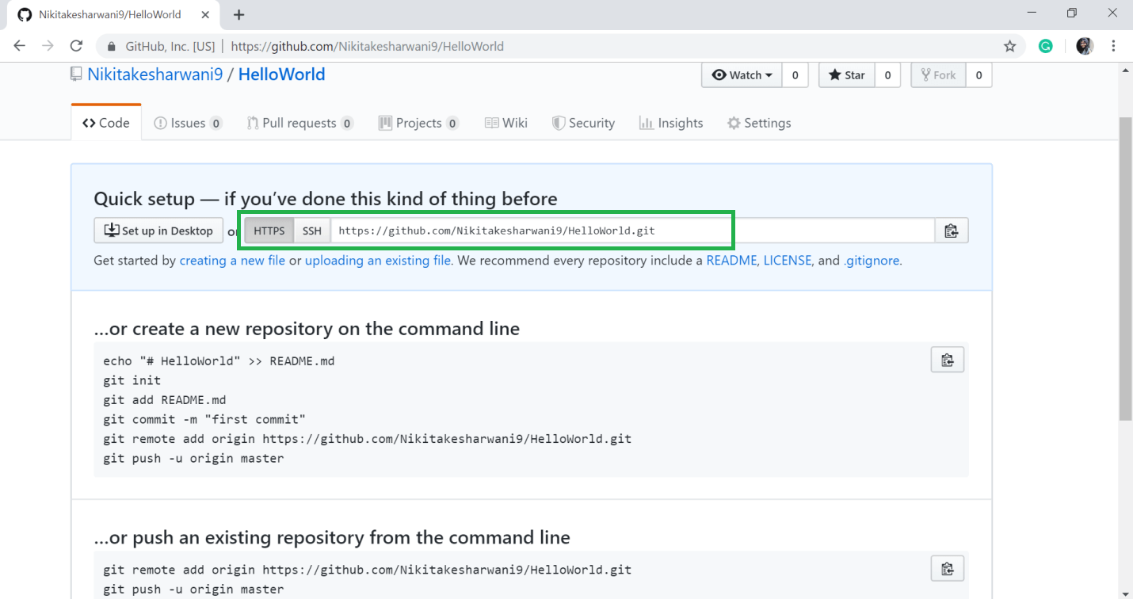

* Your repository is created. Copy the repository URL. My repository URL is: [https://github.com/Nikitakesharwani9/HelloWorld.git](https://github.com/Nikitakesharwani9/HelloWorld" \t "https://www.javatpoint.com/_blank)
* Open the command prompt in your Windows and go to the path where your java file is created.
* Then run the following command.

1. git init
2. git status
3. git add .
4. git status

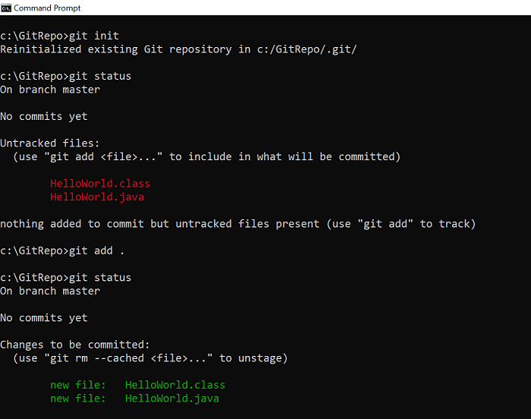

* Configure your GitHub account in your system.

1. git config --global user.email "your@email"
2. git config --global user.name "username"

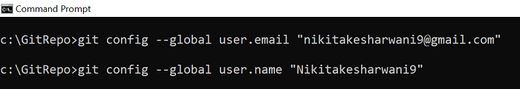

* Commit it and add the repository URL.

1. git commit -m "added HelloWorld program"
2. git remote add origin https://github.com/Nikitakesharwani9/HelloWorld.git
3. git push -u origin master

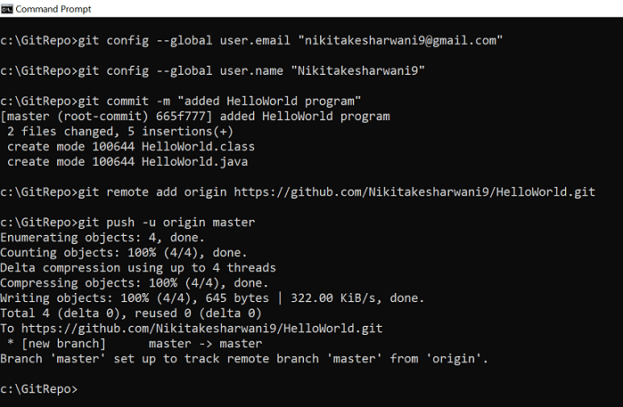

* Now, when you refresh your GitHub account, the helloWorld file will be added in your repository.

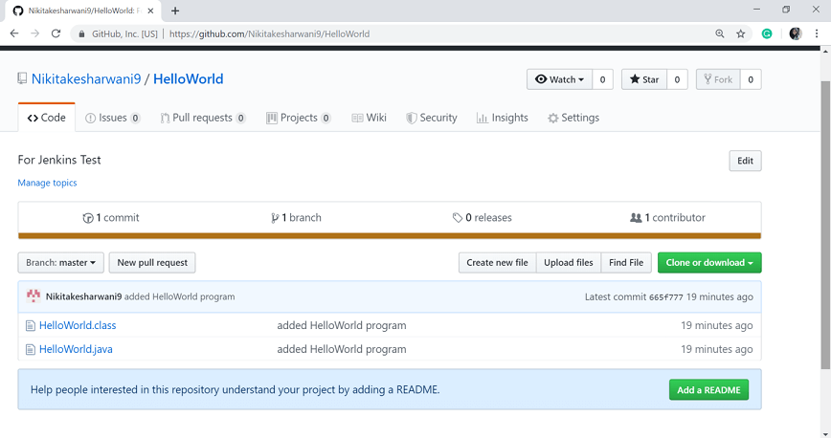

**Step 5:** Add the Repository URL in the **Source Code Management** section.

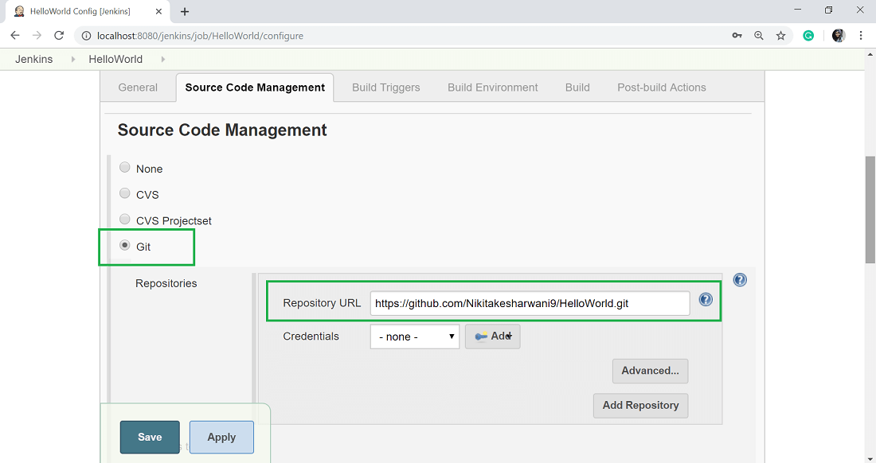

You can also use a local repository. And if your GitHub repository is private, Jenkins will first validate your login credentials with GitHub and only then access the source code from your GitHub repository.

**Step 6:** Now, it is time to build the code. Click on "**Add build step**" and select the "**Execute Windows batch command**".

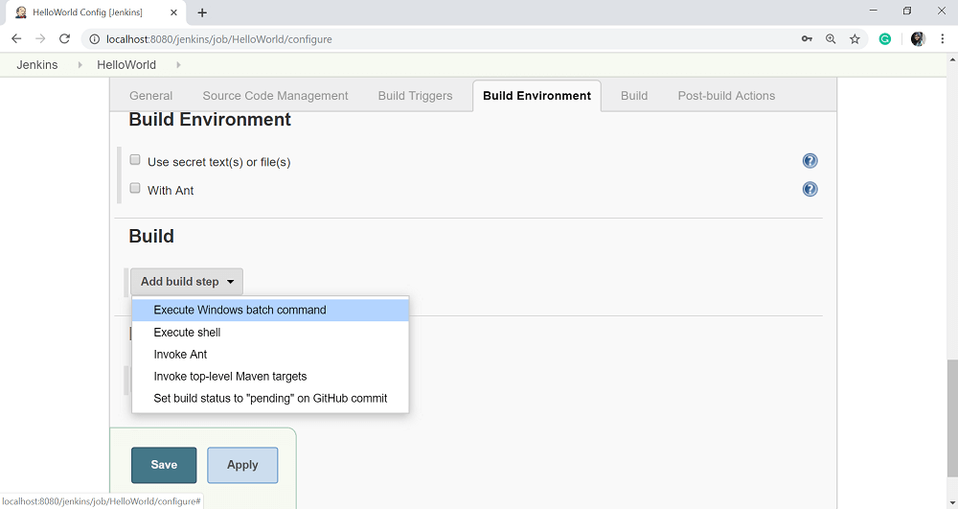

**Step 7:** Enter the following command to compile the java code.

1. javac HelloWorld.java
2. java HelloWorld

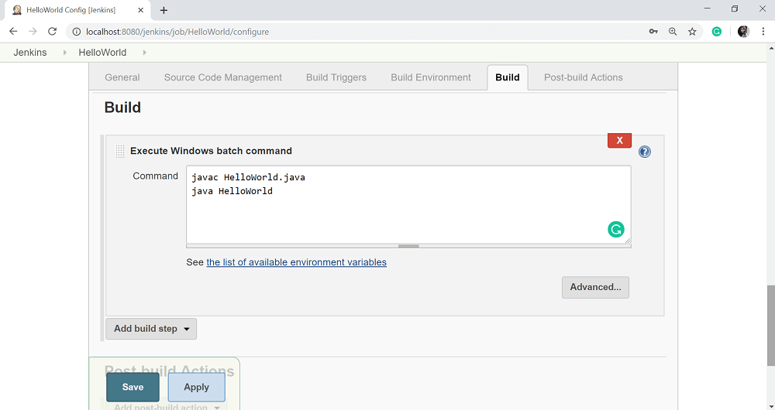

**Step 8:** Click Apply and then Save button.

**Step 9:** Once you saved the configuration, then now can click on **Build Now** option.

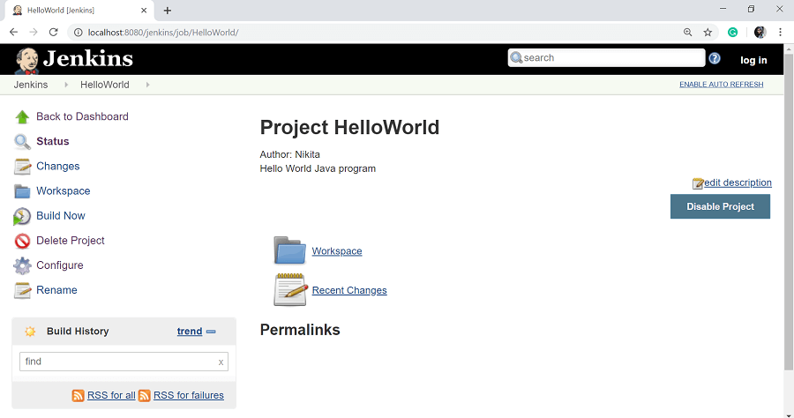

**Step 10:** After clicking on **Build Now**, you can see the status of the build on the Build History section.

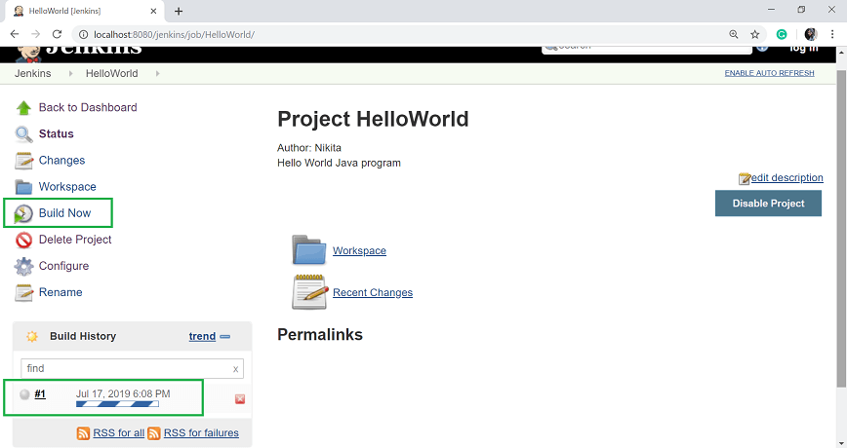

Once the build is completed, a status of the build will show if the build was successful or not. If the build is failed then it will show in red color. Blue symbol is for success.

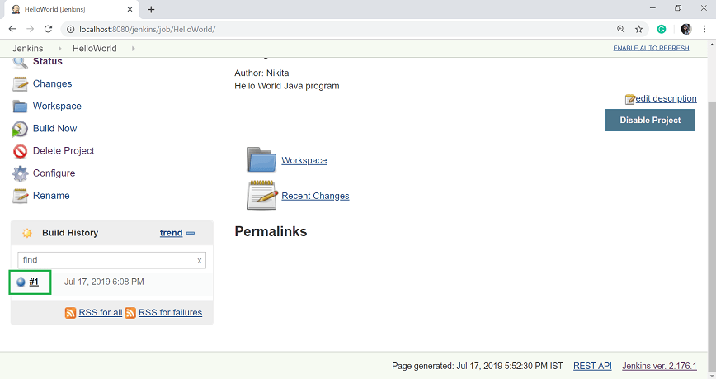

Click on the build number **#1** in the **Build History section** to see the details of the build.

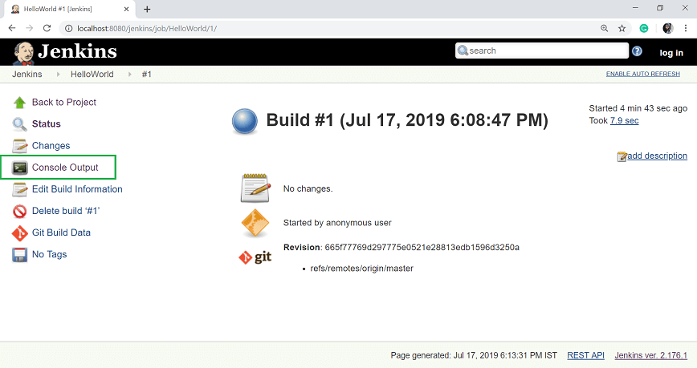

**Step 11:** Click on **Console Output** from the left side of the screen to see the status of the build you run. It should show the success message.

